Writing Assignment 2

1. Mongol Passport (Paiza):

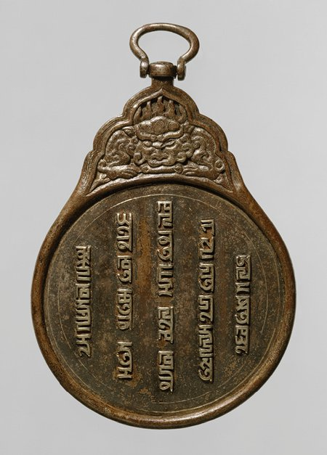
Image Source: https://share.google/s8ezzIYD8zVjOVodq

Mongol Paiza is a small metal object made of bronze, silver or gold. It was an important object in Mongol empire. Important travelers, merchant, messengers and officials were usually given this object to travel long distance safely. This Paiza acted as a passport back then.
Along with its silver and gold design it had inscriptions written on it. This inscription was the showcase of authority of Mongol rulers, the Khan. These inscription ware written on many languages Mongolian, Persian and Chinese. This shows how diverse the Mongolian empire already was.
This small object represented economic and administrative exchange. The Paiza allowed the traveler to move safely along the trade routes like silk route. It gave them the access of food, shelter or even free horses exchange during their journey (Atwood, n.d.).
It also enhanched the cultural exchange. As the Paiza holders could travel freely and safely over the huge Mongol empire they carried stories, knowledge, technologies and tradition with them. To conclude, this small object carried a big role in interchanging culture and building connection.

2. Yuan Blue and White Porcelain:

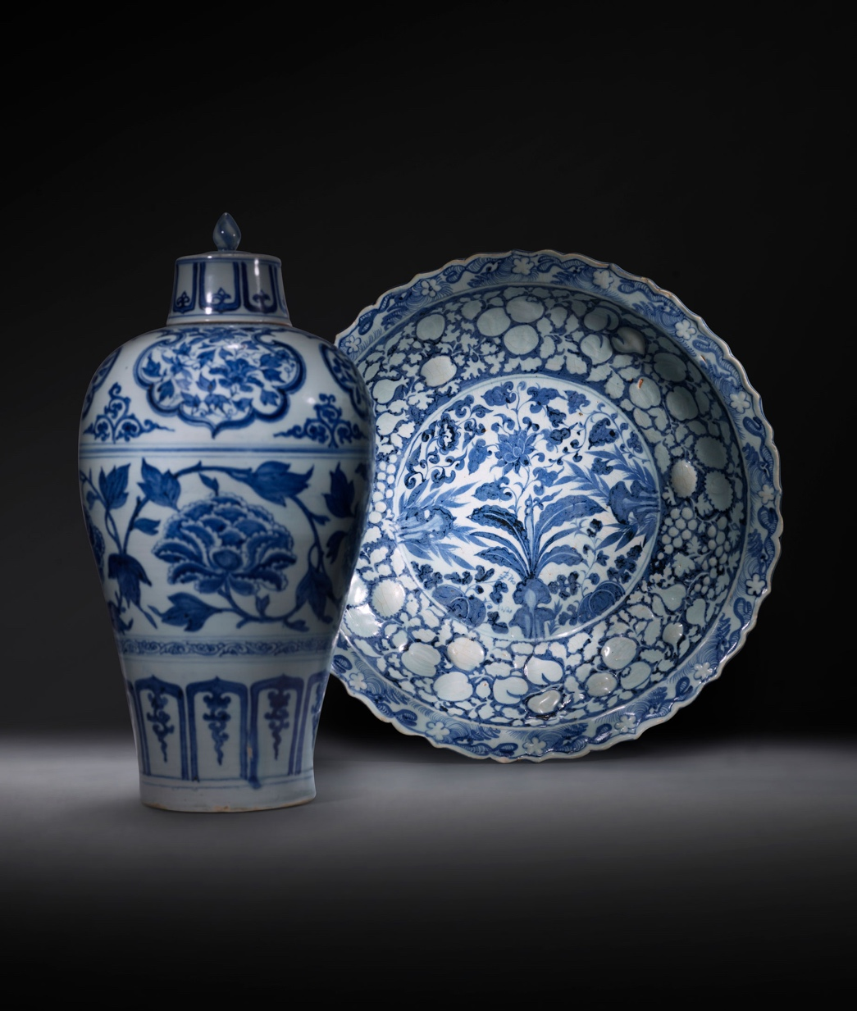
Image Source: https://share.google/p570jErQtkBeebDs5
The Yuan Blue and White Porcelain were one of the most beautiful artifacts of China. These ceramics were made in China during the Mongol period. But the interesting thing is these ceramics had other region’s influence on them. This makes it an object of cultural exchange.
This blue color design was inspired from cobalt, which used to be imported from Persia (WilliamChan17,2025). This showcases the cultural connection between China and Persia, the Eastern Asia and the Middle East. Also, some design patterns were not originated from China. Isome of its pattern symbolizes the Islamic arts and design. Which indicates that the movement and interaction of Muslim artist and traveler across the Mongol Empire.
This object clearly highlights the cultural mix of different region. Techniques from China, Materials from Persia and artistic pattern from Islamic region all together in one place. Which shows us how different cultures blended with each other.
This Porcelain is not only a decorative object, it also tells us a back story of cultural exchange.

3. The Mariner’s Compass:

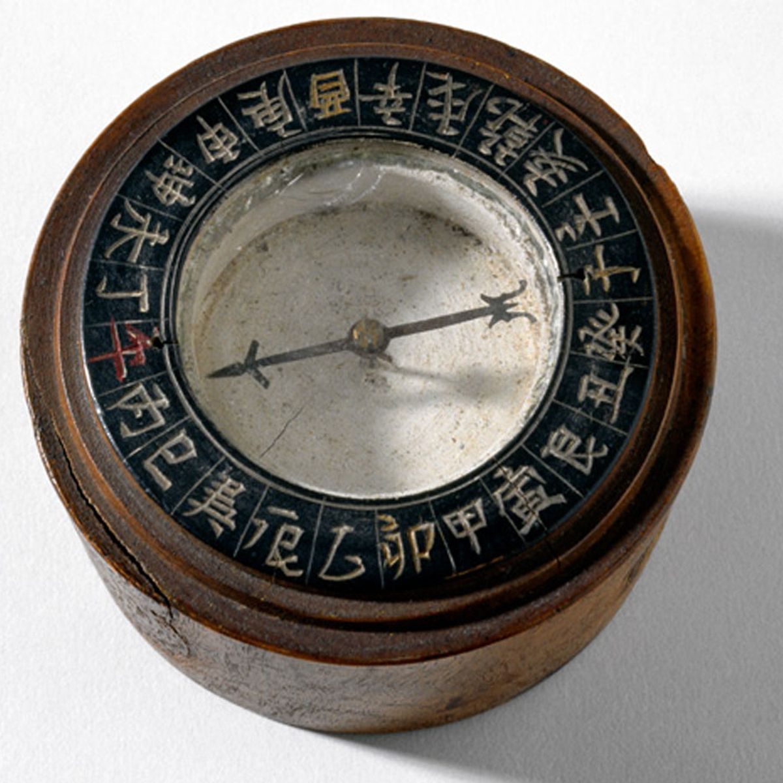
Image Source: https://share.google/YdBIVI7jBmYJeGYQV

The Mariner’s compass seems a simple object but its impact was huge. This compass was developed in China. This compass allowed the sailor and merchant to travel across the sea accurately.
The compass was based on magnet’s behavior, to point toward North. Typically, the compass had a magnetic needle placed in center with circular body around it. Though it was simple it was revolutionary.
This technology did not stay only in China. The increased interaction with other regions spread the use of compass across the other part of the world. This technology eventually reached Middle East and Europe. Which indicates the technological exchange during that period.
As the navigation got better with the use of this compass, the travel and trade across the sea route increased even more. People got more opportunity to meet other people, do businesses and share thoughts. This built up new connections between different regions.

References:
Atwood, C.P. (n.d.). Mongol mesenger’s badge (Paiza or Gerege) in Pakpa script Mongol empire. Rubin Museum of Art, Project Himalayan Art. https://rubinmuseum.org/projecthimalayanart/essays/mongol-messengers-badge-paiza-or-gerege-in-pakpa-script/
WilliamChan17. (2025, October 22). The history of blue and white porcelain: A journey of a thousand years. Medium. https://medium.com/@owlchenweiliang219/the-history-of-blue-and-white-porcelain-a-journey-of-a-thousand-years-33d4a10211c6

